Christmas 2018 Gift giving in Illian Iriga
For four decades, the Aetas lived in Mount Asug, they existed through extracting Abaca Hemp, gathered and smoked the coconut and they planted rootcrops. There was no school in Mount Asug, the reason why the elderly are illiterate. During the time of dictatorial form of governement, Mt Asug was the hide out of the anti governement movement. They exploited and abused the Aetas with their harvest and animals. The poor minorities who by nature are shy, humble and peace loving folks, went down the mountain, seek for existence. The local governement resettled the hundred families in Illian, just down the mountain, with very limited space, no chance to plant and no source of drinking water. The flowing river is down the Ilian hill, the Aetas wash their clothes, bathe and fetch water from the river since they were relocated up to this time. The government did not care to connect a potable water up to now, they’re abandoned.
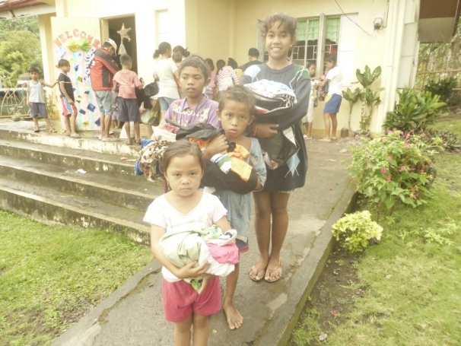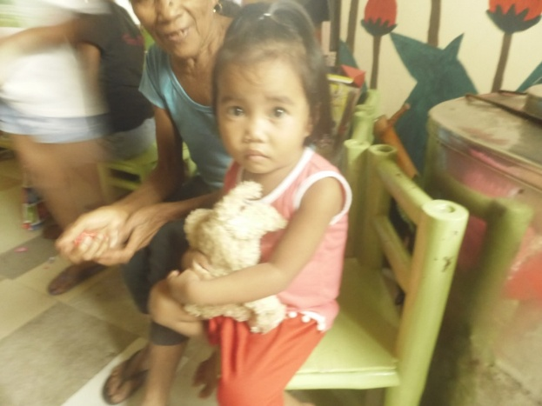
The third generation of the Aetas in Illian are recipients of our Hänsel & Gretel School. How poor the families are, but parents are now conscious of the importance of education. They are very supportive to their children in school.

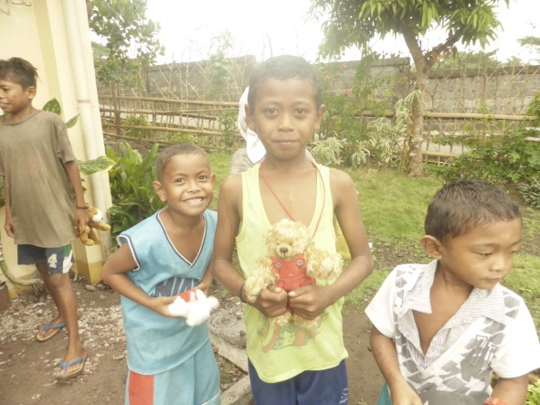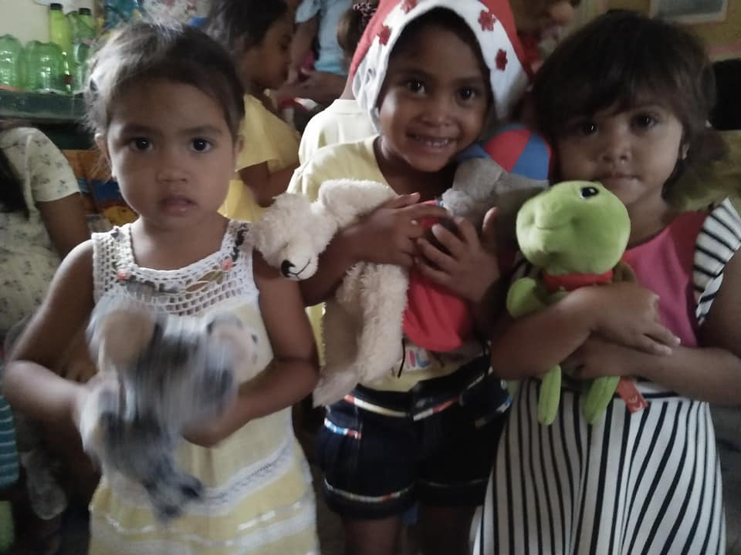

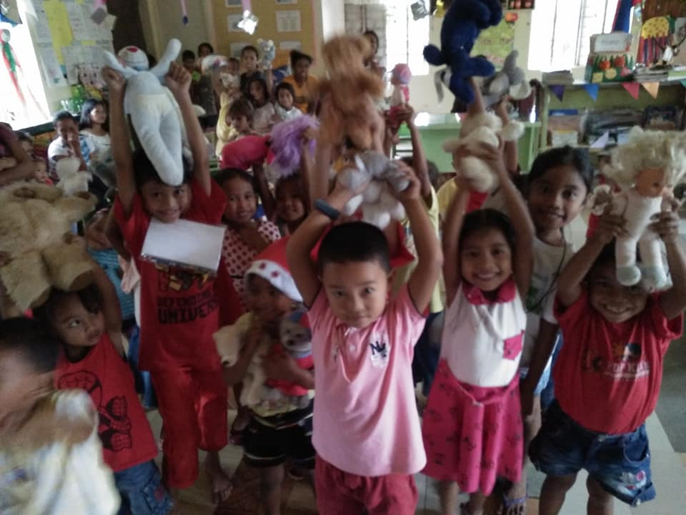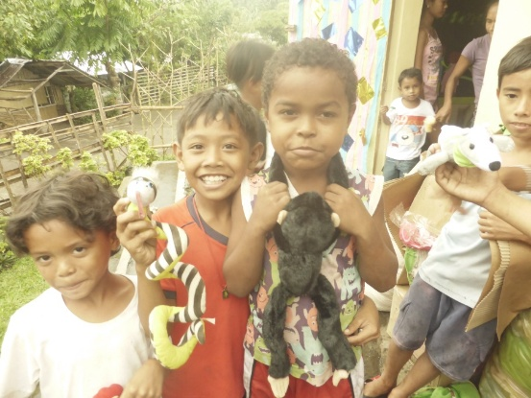
During their Christmas program, five days before Christmas, I stuffed the car with three sacks full of toys and used clothing collected from our Hänsel & Gretel Schools in the lowland, and surprised all children and parents. All children with in the tribe were so curious, years ago up in Mount Asug, Christmas present was unknown to them. No wonder, parents and all children inside and outside the school would like to have. It was a very happy moment for all.

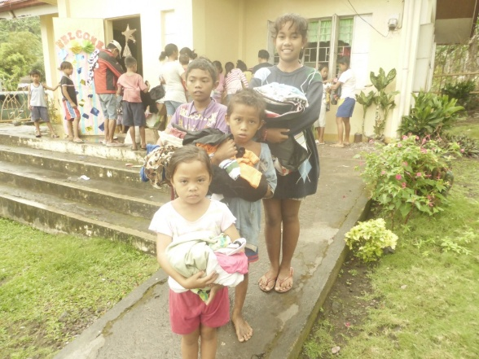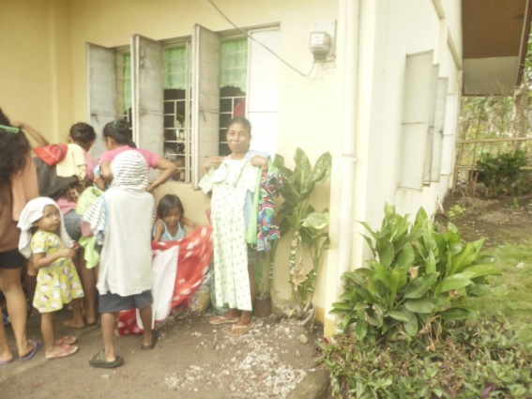

They all went home with their hands full of clothing plus the toys.
Thank you dear Pupils, Parents, Teachers in Dürscheid, Olpe, Kürten, and to Ute Glaser for the continuous love for the less privileged here in Camarines Sur this Christmas days!

