Hänsel & Gretel Foundation, Inc.
No. 75 San Vicente, Canaman, Camarines Sur

SEC Reg. 11999-00210/ DepEd Govt. Permit(R-V)No. 122 s. 2015
CP: 09291448929 Email:cdapilos@yahoo.com.ph

January 15, 2020
Dear Pupils, Parents and Teacher Team,
A Prosperous New Year 2020!
Thanks to the present technology, we are well informed of what is going on globally. It makes me sad, ashamed and feel pitiful that the news featured about the Philippines is more of natural catastrophes as mighty typhoon, flood, landslide, earthquakes and deadly volcanic eruption, though it is the reality.
What follows after such natural calamities are but damaged houses, buildings as schools and plantations. 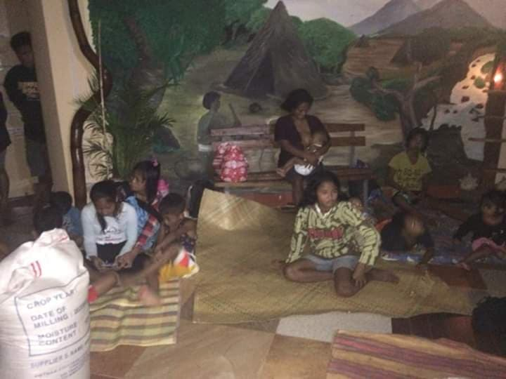 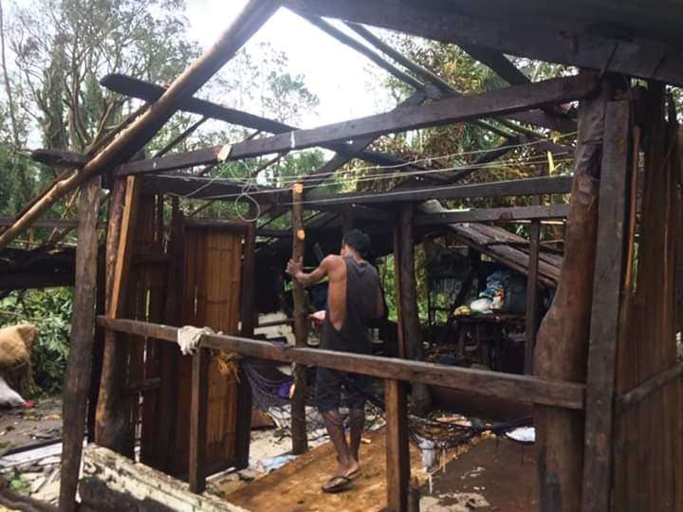
Aeta families spent their nights in our school during the typhoon, their palm huts were destroyed from heavy rain and storm.
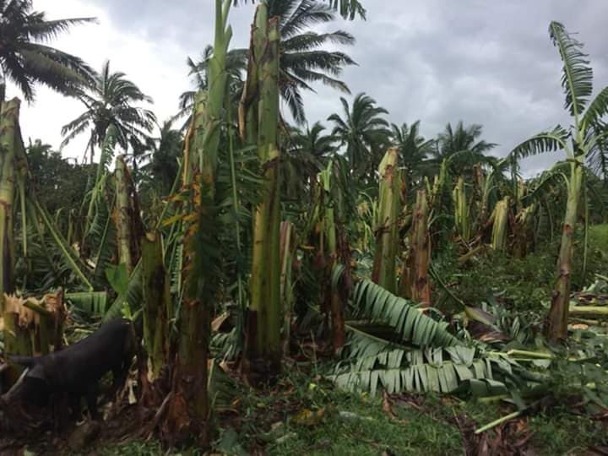
All bananas and vegetables were damaged, it will take one year before it will bear fruits
Really miserable, however beside the suspended classes, we have pupils who ignore the storm, they come to school for fear to get absent. Months before, they all expect the coming of Saint Nikolaus with toys. Saint Nikolaus day is a tradition in our Haensel & Gretel Schools not only for our pupils but for parents as well. They were inspired to learn and behave very well feeling the real spirit of Christmas. Saint Nikolaus did never fail to come for 3 decades now, regardless of sunny or stormy weather, with his sacks full of “ your toys”.
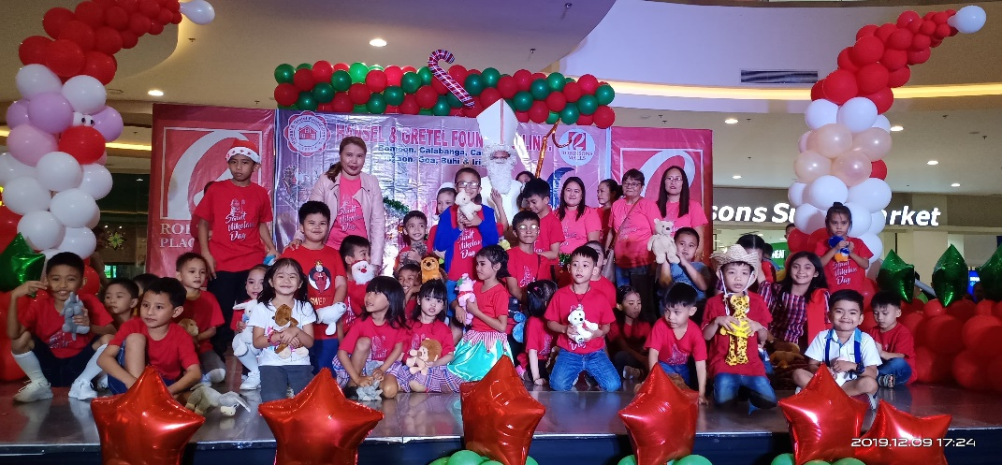
Some pupils from our Haensel & Gretel Canaman

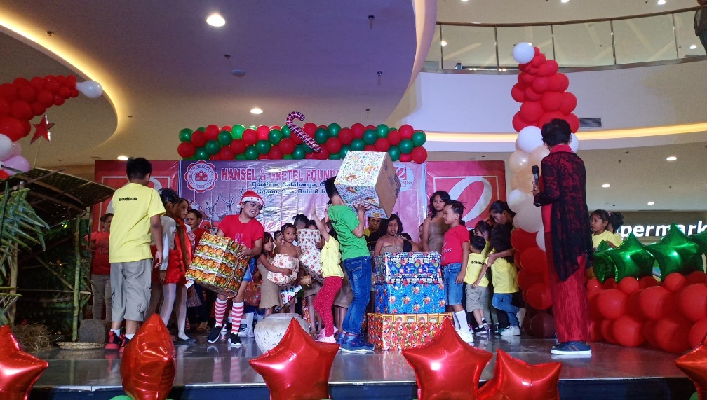
Our Aeta Pupils received boxes of used clothing from our lowland pupils.
Lastly, day before Christmas, to witness how the eyes glow of children and grateful parents in distant village being surprised, with unexpected toys from someone far and unknown in the midst of their emptiness is touching, for them a heavenly joy!
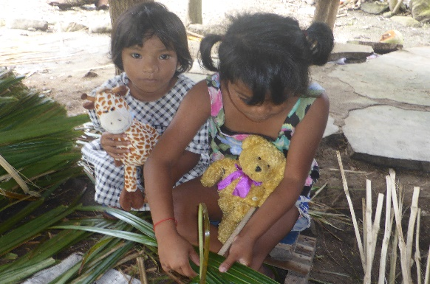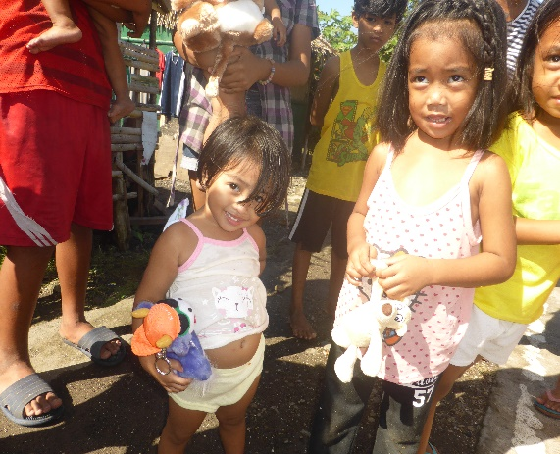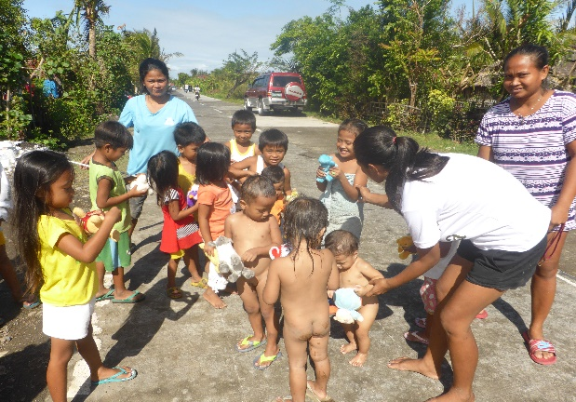
Every Christmas children from selected distant village received toys as well.

I feel so grateful for the meaningful Christmas you always shared to our children here in Camarines Sur!

Sincerely,
Carmen Dapilos

